Report

Add the items of interest in the report and get the generated report by clicking on the **Report** button.

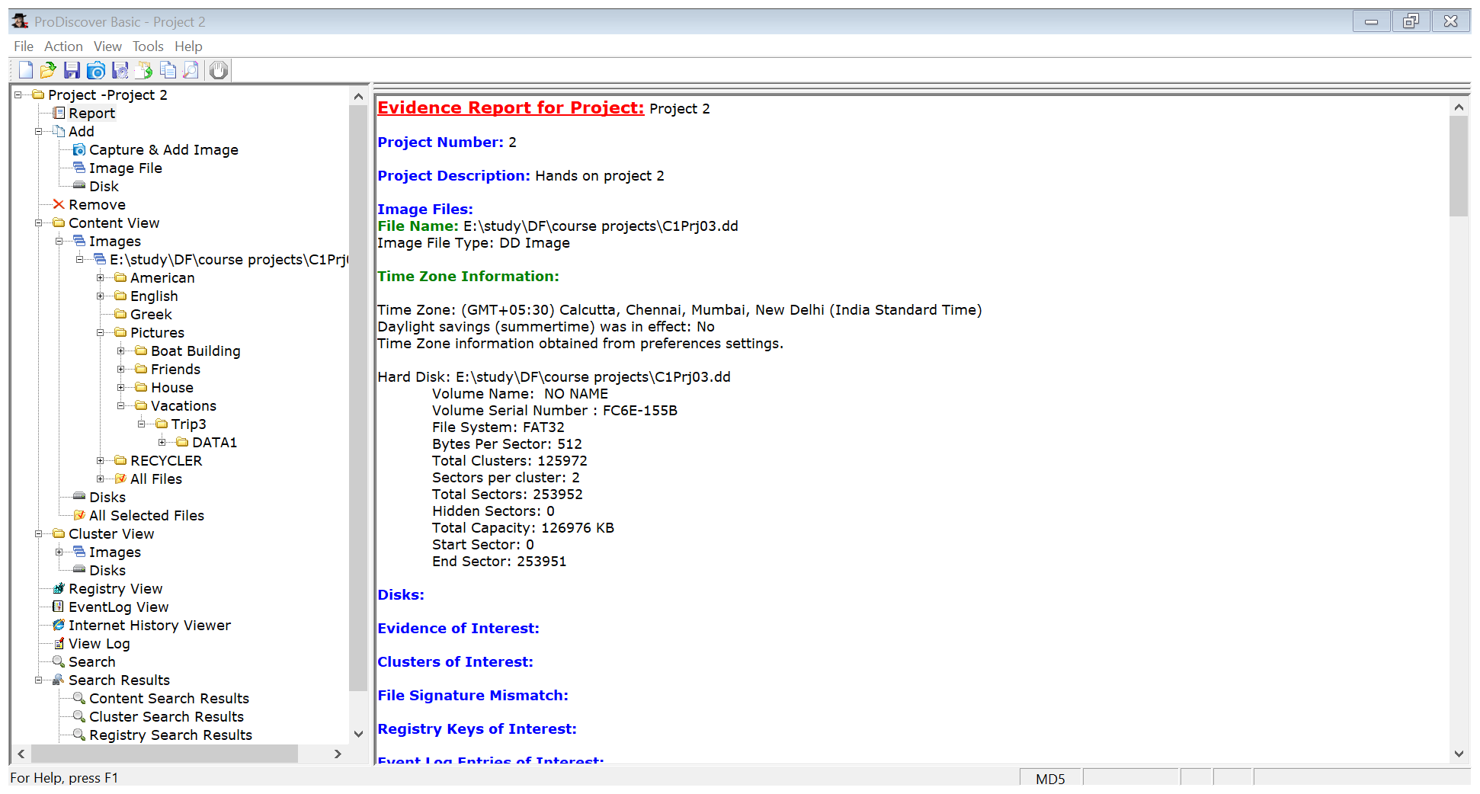

We can get the generated report in our system. Simply, click on the export icon () Choose the format of the report and enter the destination to store the report and click ok.



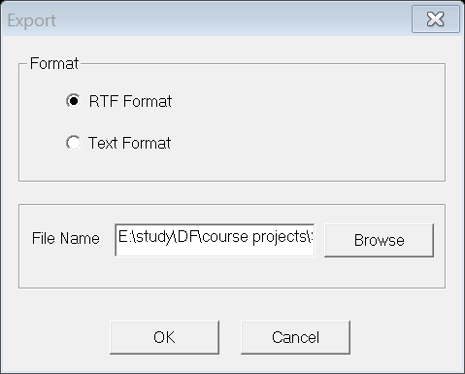

The generated report will be stored at the specified location. Now we can easily view the report whenever we want and can share with the other person.